



System Status & Availability Report

Apr 2024

Document nr.: PO-POX2024-04

Revision: 1

Date: Apr 2024

**Author: Raunak Sharma**

**Table** **of Contents**

© 2024 Project Objects Ltd

1. Server Utilization Statistics 2

1.1. Application Server 2

1.1.1. CPU 2

1.1.2. Memory 2

1.2. Database Server 3

1.2.1. CPU 3

1.2.2. Memory 3

2. Service Hours & Uptime 4

2.1. Approved & Planned Downtime 4

2.2. UNPlanned Downtime 4

2.3. Calculated Service Time 4

3. Planned Downtime for Next Quarterly Updates (TENTATIVE dates and time) 4

4. Support Status Overview 4

5. STorage Statistics on Azure (For AXA only) 5

# Server Utilization Statistics

Server’s performance and availability during the reporting period from the 1st of Apr to the 30th of Apr remains good and everything is stable, and no server outage period has been recorded during this period due to load on servers.

## Application Server

### CPU

The below graph shows the average utilization of CPU over the reporting period, we can see that the monthly average CPU utilization is around 16% and the max average CPU usage peak also remained below 65% throughout the reporting period.

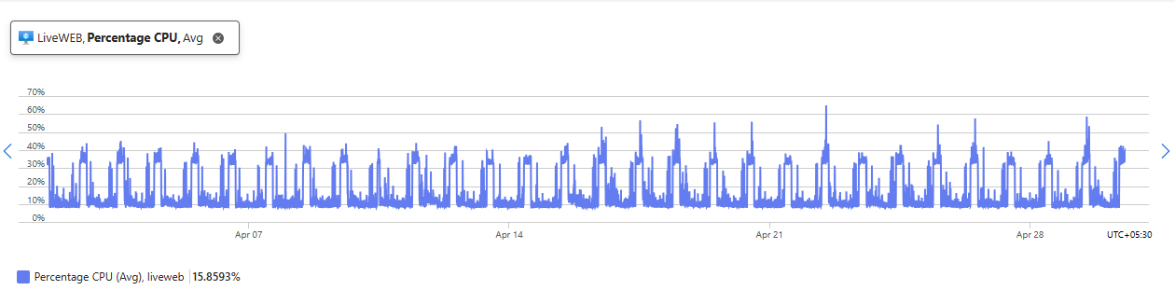

### Memory

Below is the Memory availability graph, it shows that almost 37 GB Avg memory remains available.

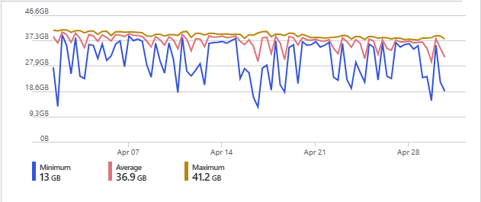

## Database Server

### CPU

The below graph shows the average utilization of CPU over the reporting period, we can see that the monthly average CPU utilization is around only 5% and the max average CPU usage peak also remained below 52% throughout the reporting period.

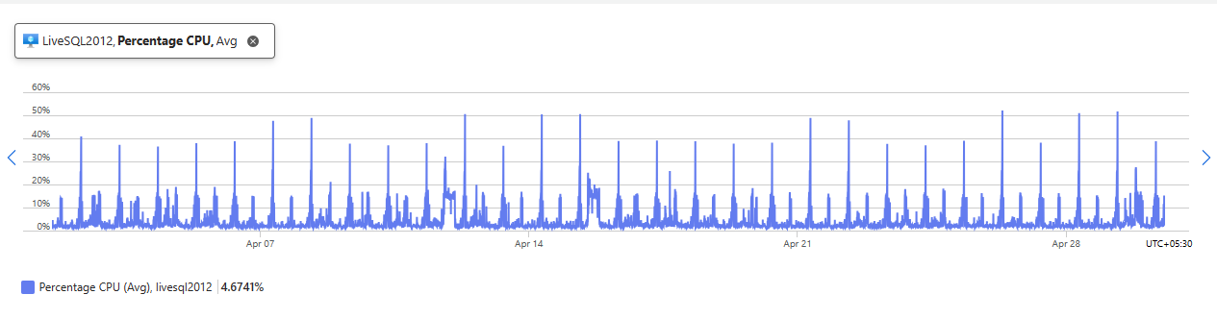

### Memory

Below is the Memory availability graph, it shows that almost 4 GB Avg memory remains available.

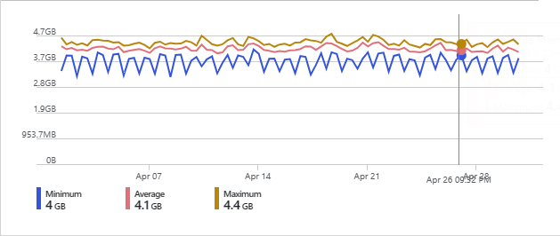

# Service Hours & Uptime

## Approved & Planned Downtime

There is no planned downtime on the servers for April month.

## UNPlanned Downtime

There is no unplanned downtime happened on the servers for April month.

## Calculated Service Time

Period: 1st of Apr until 30th of Apr.

Total Guarantee uptime is 99,6% as per the various SLAs.

During April the summary of **unplanned** downtime was 0,00 hours which gives a calculated uptime of ((30 days * 24) – 0,00) / (30 days * 24 hours) =**100%,** and therefore have maintained service uptime in line with the respective SLA.

# Planned Downtime for Next Quarterly Updates (TENTATIVE dates and time)

There is no planned update date confirmed as of now.

# Support Status Overview

The table below shows the support request statistics from the 1st of Apr to the 30th of Apr.

|  |  |  |  |  |  |  |  |
| --- | --- | --- | --- | --- | --- | --- | --- |
| **Request Type** | | **Total** | **Closed** | **Open** | | | **On Hold** |
| In Progress | At customer side | Awaiting customer confirmation |
| Bug |  | **2** | 2 | 0 | 0 | 0 |  |
| Enhancement | **2** | 2 | 0 | 0 | 0 |  |
| Query/Information | **4** | 2 | 0 | 2 | 0 |  |
|  | | | | | | | |
| **Total** | | **8** | **6** | **0** | **2** | **0** | **0** |

No major issues have been discovered that would require follow-up action.

# STorage Statistics on Azure (For AXA only)

The table below shows the storage details from 1st of Apr to the 30th of Apr.

|  |  |  |  |  |
| --- | --- | --- | --- | --- |
| **S.NO** | **Type** | **DB Types** | **Calculation for Size** | **Size (Gib)Approximately** |
| 1 | VM Disk Storage | Transactional |  | 8.4 |
|  |  | VOLT |  | 5.4 |
|  |  | Reporting |  | 18.2 |
|  |  | Mirror |  | 8.4 |
|  |  |  |  | **40.4** |
| 2 | Backup Policy |  | Total storage size * 30 days |  |
|  | 30 days retention period |  | (40.4*30) | 1212 |
| 3 | ASR |  | Replication of storage | 40.4 |
|  | Disaster Recovery Solution |  |  |  |
|  |  |  | **TOTAL** | **1292.8** |

Here,

1. Transactional DB represents the storage of application data.
2. VOLT DB shows the storage of document attachments on our server.